1 Install R

* [Download R-3.6.3](https://cran.r-project.org/bin/windows/base/) (windows) or [R for Mac OS X](https://cran.r-project.org/bin/macosx/) (mac)
  + Select CRAN: Canada (UofT): <http://cran.utstat.utoronto.ca/>
    - “Comprehensive R Archive Network” (CRAN) is a collection of sites which carry identical material, consisting of the R distribution(s), the contributed extensions, documentation for R, and binaries.
* [Download RStudio](https://rstudio.com/products/rstudio/download/#download)
  + RStudio is an integrated development environment (IDE) for R that provides an alternative interface to R
  + RStudio provides integrated support for editing and executing R code and documents.
  + Divided into 4 panes
  + 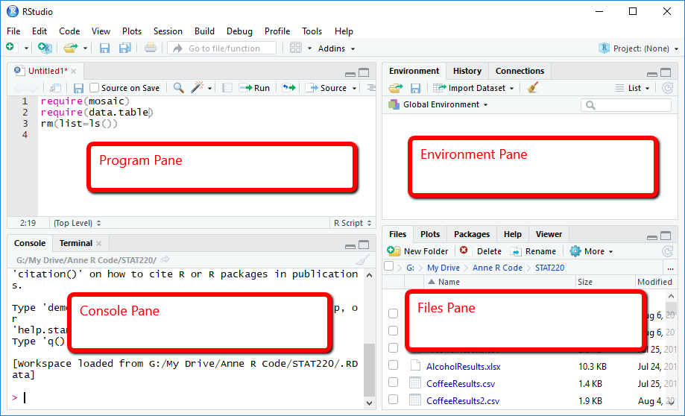
  + [Read more about RStudio](https://bookdown.org/ageraci/STAT160Companion/intro.html)
  + Write code interactively in “console pane” and make scripts in “program pane”
* Terms:
  + **File path** = the route to a file (file = “file” or folder)
    - * Absolute = the route starts at “home” node

e.g. “/home/Documents/myReport” (mac) or “C:\home\Documents\myReport” (windows), “C:\home\Documents\myReport\report.txt”

* + - Relative = refers to file that you can access if you start at current working directory

e.g starting in the “home” folder: “Documents/myReport”

* + - [Read more: What Is a Path?](https://docs.oracle.com/javase/tutorial/essential/io/path.html)
  + **Command** = instruction given by a user telling a computer to do something
    - Examples
      * getwd() # print your current working directory
      * setwd(dir_path) # sets your working directory

*change windows path’s “\” to “/” or “\\”

* + - * q() # quit
    - [Practice: the Workspace](https://www.statmethods.net/interface/workspace.html)
    - https://www.statmethods.net/interface/workspace.html
  + **Script** = a list of commands that are executed by a certain program
    - Write/code in R in “program pane”

# Code from today

# = comment out lines

getwd()

# [1] "C:/Users/Kazeera/”

path = "Documents" #relative path

path = "C:/Users/Kazeera/Documents" #absolute path